Abstract— Paragraph 1 blah blah. This is the abstract and I’m going to copy and paste this next sentence over and over so you know. Keep the abstract as one big paragraph. Keep the abstract as one big paragraph. Keep the abstract as one big paragraph. Keep the abstract as one big paragraph. Keep the abstract as one big paragraph. Keep the abstract as one big paragraph. Keep the abstract as one big paragraph. Keep the abstract as one big paragraph. Keep the abstract as one big paragraph. Keep the abstract as one big paragraph. Keep the abstract as one big paragraph. Keep the abstract as one big paragraph. Keep the abstract as one big paragraph. Keep the abstract as one big paragraph. Keep the abstract as one big paragraph.
Keywords— Direction-of-Arrival (DoA), Azimuth, Elevation, localization, Uniform Linear Array (ULA), Uniform Circular Array (UCA), Signal to Noise Ratio (SNR), Root Mean Squared Error (RSME),

INTRODUCTION
In recent years, unmanned aerial vehicles (UAVs) have become more common in commercial, industrial, and defense settings, which has increased interest in practical ways to track and locate them. Small UAVs can be difficult to detect and localize consistently because they may fly low, change direction quickly, and transmit relatively low-power RF signals, while optical sensors like LiDAR typically require the target to be within the sensor’s field of view and can be affected by clutter or multipath. This work presents a real-time RF localization prototype capable of estimating the azimuth, elevation, and range of a single static or moving 2.4 GHz RF source. Angular estimates are obtained using multi-element antenna arrays and subspace-based DoA algorithms, while range is measured using a mechanically steered LiDAR unit. Multiple array configurations, including ULA/UCA and orthogonal ULA/ULA arrangements, are evaluated alongside MUSIC and ESPRIT algorithms under consistent indoor test conditions. Performance is quantified using mean angular error and standard deviation across varying SNR levels and snapshot counts to determine the most accurate and stable configuration for single-source localization.

Project Objectives

The primary objective of this project is to develop a real-time radio frequency (RF) localization system capable of estimating the azimuth, elevation, and range of a single moving RF source. Angular localization (azimuth and elevation) is achieved through direction-of-arrival (DoA) estimation techniques, while range information is obtained using a LiDAR-based distance sensing system. The estimated angular coordinates are used to mechanically steer a pan-and-tilt LiDAR apparatus, enabling full localization in spherical coordinates (φ, θ, r).

To achieve angular estimation, multiple antenna array geometries are investigated, including Uniform Linear Array (ULA) and Uniform Circular Array (UCA) configurations. Hybrid array combinations consisting of ULA/UCA and orthogonal ULA/ULA arrangements are implemented to evaluate their suitability for two-dimensional DoA estimation.
In addition to hardware configuration comparisons, multiple subspace-based estimation algorithms are evaluated. These include Multiple Signal Classification (MUSIC) and Estimation of Signal Parameters via Rotational Invariance Techniques (ESPRIT). Performance is assessed under consistent indoor testing conditions using a single 2.4 GHz RF source.
Quantitative evaluation metrics include the mean angular error and standard deviation of azimuth and elevation estimates across Monte Carlo simulations and experimental trials. These metrics are used to determine the most accurate and stable array–algorithm configuration for single-source localization. The overall goal is to identify a system architecture that provides reliable, low-variance angular estimation suitable for real-time implementation.

Project Deliverables

The aim of this project is to deliever a real-time system that preforms DoA estimations for a single RF source. The demonstration displays azimuth and elevation estimates produced from the array processing chain and support end-to-end operation using the competition hardware stack. When integrated, the demonstration also includes LiDAR-based ranging driven by the DoA output to enable full (φ, θ, r) localization within the defined test environment.

Additional deliverables include documented software and hardware support packages to ensure reproducibility of results. These materials consist of MATLAB scripts, CAD drawings, configuration files, experimental datasets, and detailed setup instructions outlining required dependencies. A formal test procedure will be provided to define the experimental configuration, calibration steps, parameter settings, and evaluation metrics, enabling independent replication and validation of system performance. Supporting documentation will be included within this paper or provided as separate appendices for comprehensive analysis.

MATHEMATICAL BACKGROUND
This section develops the mathematical background for the subspace-based direction-of-arrival (DoA) estimation techniques evaluated in this study. Based on narrowband signal modeling, the derivations of the MUSIC and ESPRIT algorithms are presented, emphasizing their subspace decomposition principles and their applicability to the array geometries considered.

Multiple Signal Classification (MUSIC)

The MUSIC method is a widely used high-resolution, subspace-based method widely applied in array signal processing. As illustrated in Fig. 1, a far-field source impinging on a uniformly spaced antenna array produces time-shifted and phase-shifted measurements across the sensor elements. These spatial phase differences encode the incident direction of the source. MUSIC exploits the structure of the array covariance matrix to decompose the received data into orthogonal signal and noise subspaces.
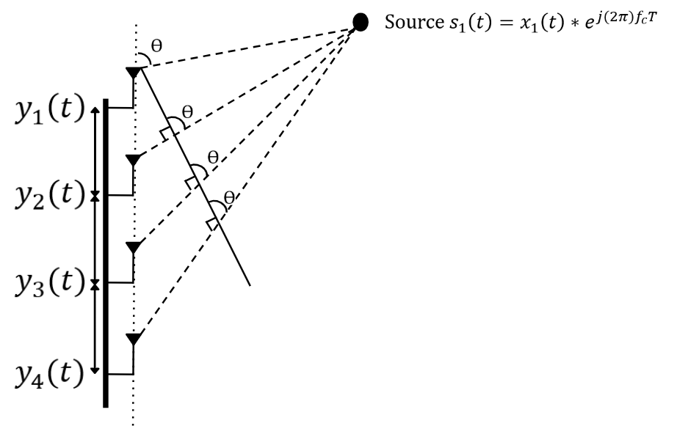
Fig 1. MUISC DoA Model with Source impinging on ULA

Due to the propagation delay between adjacent antenna’s, the incident wave produces progressive phase shifts across the array elements that depend on the angle of arrival 𝜃. The received array measurements at time 𝑡 can be expressed as a column vector whose entries correspond to the signals observed at each antenna element. Under the single-source assumption, the array output is modeled as the product of a direction-dependent steering vector and the transmitted signal, corrupted by additive noise. The received signal vector is therefore written as:

$$Recieved Values Steering Vector Noise Vector$$
$$Y\left(t\right) = A(Ө)*s_{1}(t) + N(t)$$
$$\left|\begin{matrix}y_{1}\left(t\right) \\ y_{2}\left(t\right) \\ y_{3}\left(t\right) \\ y_{4}\left(t\right)\end{matrix}\right| = \left|\begin{matrix}1 \\ e^{-jdksinӨ} \\ e^{-j2dksinӨ} \\ e^{-j3dksinӨ}\end{matrix}\right|x_{1}\left(t\right)*e^{j\left(2π\right)f_{c}T} + \left|\begin{matrix}N_{1}\left(t\right) \\ N_{2}\left(t\right) \\ N_{3}\left(t\right) \\ N_{4}\left(t\right)\end{matrix}\right|$$

After collecting 𝑁 time samples (snapshots) of the received vector y(t), the spatial information contained in the inter-element phase differences is captured through the sample covariance matrix. This covariance aggregates the cross-correlations between antenna channels and suppresses uncorrelated noise as the number of snapshots increases. The sample covariance is estimated as:

${\hat{R}}_{x}=\frac{1}{N}\sum_{n=1}^{N}{x\left[n\right]x^{H}[n]}=\frac{1}{N}XX^{H}$ (1)

MUSIC exploits the fact that, under the single-source model, ${\hat{R}}_{x}$ can be decomposed into a rank-one signal component plus a noise component. Eigenvalue decomposition separates these contributions by partitioning the eigenvectors into a signal subspace and a noise subspace:

${\hat{R}}_{x}=UΛU^{H}=[\begin{matrix}U_{S} & U_{N}\end{matrix}]\left[\begin{matrix}Λ_{S} & 0 \\ 0 & Λ_{N}\end{matrix}\right]{[\begin{matrix}U_{S} & U_{N}\end{matrix}]}^{H}$ (2)

A key result is that the true steering vector 𝑎(𝜃) lies in the signal subspace and is therefore orthogonal to the noise subspace. Consequently, when a candidate angle 𝜃 matches the true direction of arrival, the projection of 𝑎(𝜃) onto the noise eigenvector approaches zero. MUSIC converts this orthogonality condition into a pseudospectrum by evaluating the inverse of the steering vector’s projection onto the noise subspace, The DoA estimate is obtained by searching over 𝜃 and selecting the angle corresponding to the peak:

$P_{MUSIC}\left(θ\right)=\frac{1}{a^{H}\left(θ\right)U_{N}{U_{N}}^{H}a\left(θ\right)}$ (3)

The For a Uniform Circular Array (UCA), the MUSIC algorithm itself remains unchanged; however, the steering vector must be modified to reflect the circular geometry. Unlike the ULA, where phase shifts progress linearly along the array, each UCA element is positioned at a different angular location around a circle of radius 𝑅 As a result, the phase at each element depends on the projection of the incoming wave onto that element’s position.
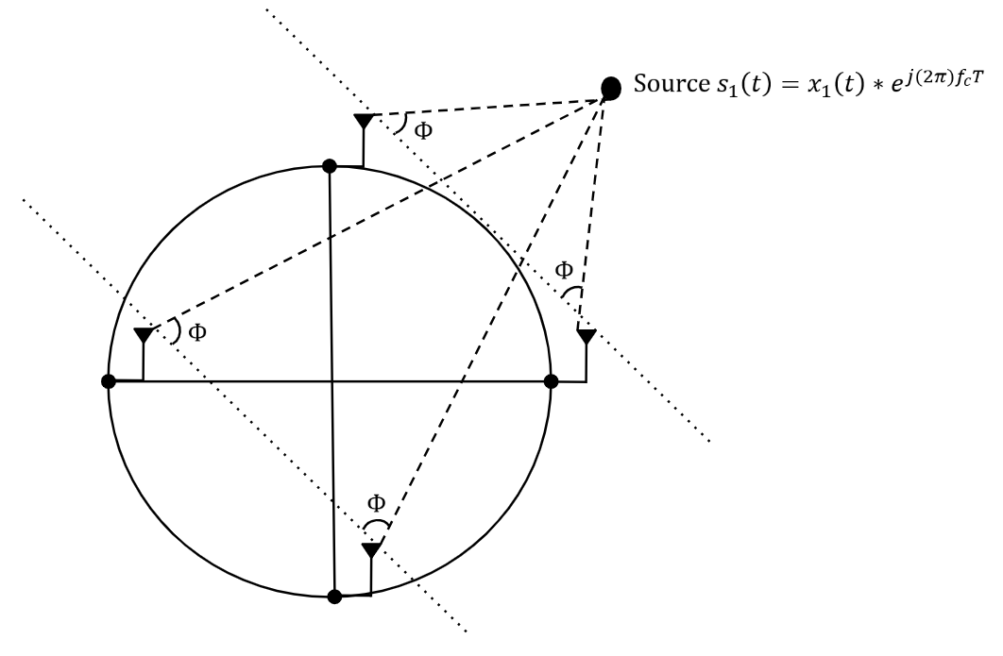
Fig 2. MUISC DoA Model with Source impinging on UCA

Estimation of Signal Parameters via Rotational Invariance Techniques (ESPRIT)

The Estimation of Signal Parameters via Rotational Invariance Techniques (ESPRIT) is a subspace-based DoA estimation method that exploits the translational symmetry of uniform linear arrays. As shown in Fig. 3, the four-element ULA is partitioned into two overlapping subarrays separated by a known spacing 𝑑. Because the incident wave produces a consistent phase progression across the array, the two subarrays observe signals that differ by a fixed phase rotation related to the angle of arrival 𝜃. ESPRIT leverages this rotational invariance within the signal subspace to directly compute the direction of arrival without requiring a spectral search.
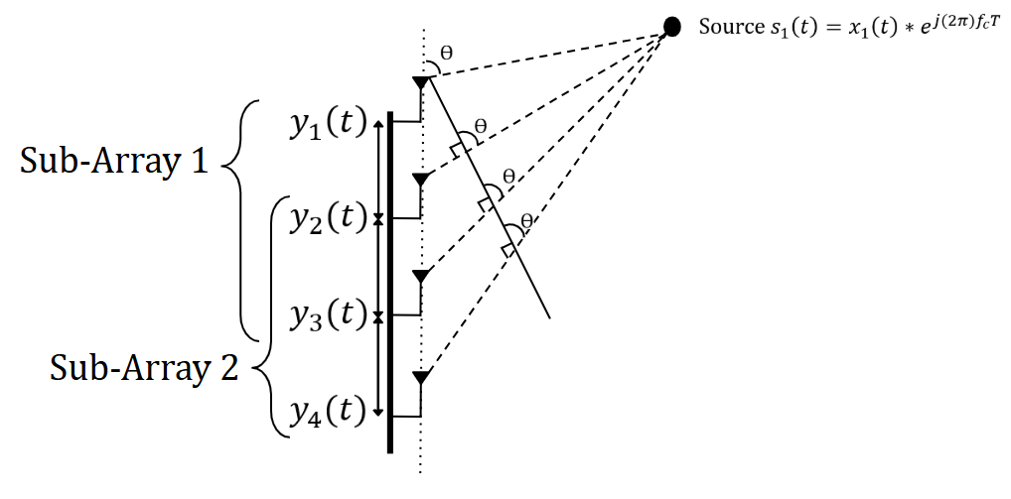
Fig 3. ESPRIT DoA Model with Source impinging on ULA

To exploit this array subspace symmetery, the signal subspace obtained from the covariance matrix ($E_{s}$) is multipled by the corresponding shifted arrays, creating the subspaces of Sub-Array 1 & 2, as seen in the equation below. the two subarrays share common elements and are separated by a known spacing 𝑑, the received signals in each subarray differ only by the phase shift induced by the incident plane wave. This relationship helps isolate the phase shift associated with the source DoA.

$E_{1}= J_{1}E_{s} E_{2}= J_{2}E_{s}$ (4)

Due to this shift invariance property, the phase difference between the separated signal subspaces contains the term kdsin($θ$) where k is the wave number. The eigenvalue associated with the subspace maintains the phase shift information, so the DoA estimation can be extracted from the eigenvalues using the equation below:

$\hat{θ}= \sin^{-1}(\frac{∆λ}{kd})$ (5)

SIMULATIONS
This section evaluates the practical performance of the proposed MUSIC and ESPRIT algorithms as implemented in this work. Monte Carlo simulations are conducted to assess robustness to noise and to model expected real-world performance. Two key parameters are analyzed: Signal-to-Noise Ratio (SNR) and number of snapshots, each evaluated with respect to DoA estimation accuracy. To ensure a fair and direct comparison, both algorithms are tested under identical simulation conditions, including array configuration, source characteristics, and noise realizations.

SNR vs, DoA Accuracy Monte Carlo Trails

The first Monte Carlo simulation evaluates the MUSIC algorithm’s immunity to noise. The elevation estimation using the ULA demonstrates strong robustness, maintaining low RMSE even at relatively low SNR values and converging to near-zero error at moderate to high SNR levels. In contrast, the azimuth estimation using the UCA exhibits a clear threshold behavior, with large estimation errors at low SNR due to poor signal and noise subspace separation. Once the SNR surpasses the threshold region, the azimuth error rapidly decreases and stabilizes. These results illustrate the inherent sensitivity of subspace-based methods to noise and highlight the influence of array geometry on estimation stability.

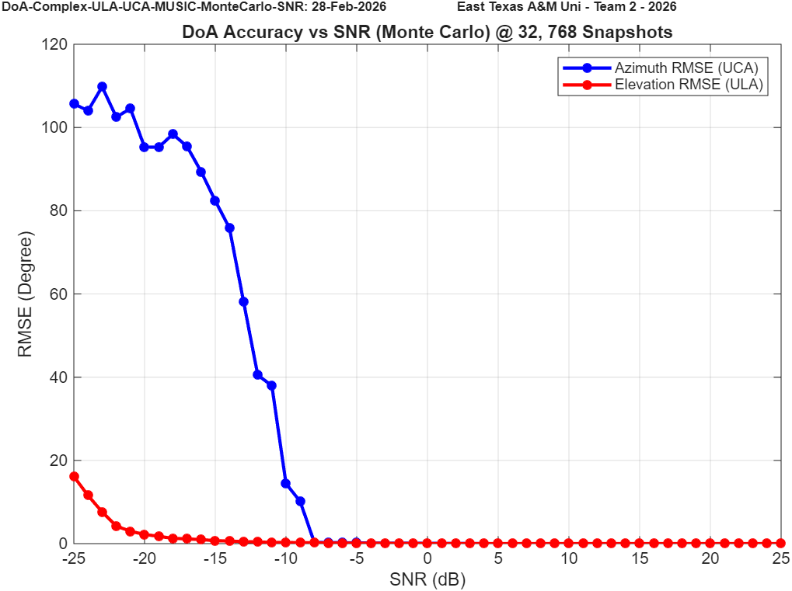
Fig 4. MUSIC ULA/UCA DoA SNR vs. Accuracy Simulation

Although ESPRIT was initially considered for both array configurations, it was not implemented for the ULA/UCA combination. The UCA does not inherently provide the required phase-shift invariance without additional transformations or virtual array mapping. Due to the limited number of elements and lack of directly paired phase-aligned subarrays for the configuration we have.

The second simulation evaluates the ESPRIT algorithm’s immunity to noise using the ULA/ULA configuration. The elevation estimation demonstrates strong robustness across the tested SNR range, maintaining relatively low error at reduced SNR and converging toward near-zero RMSE as SNR increases. Similarly, the azimuth estimation improved compared to the MUSIC simulations, meaning more reliable subspace separation and phase-shift extraction at moderate-to-high SNR values.

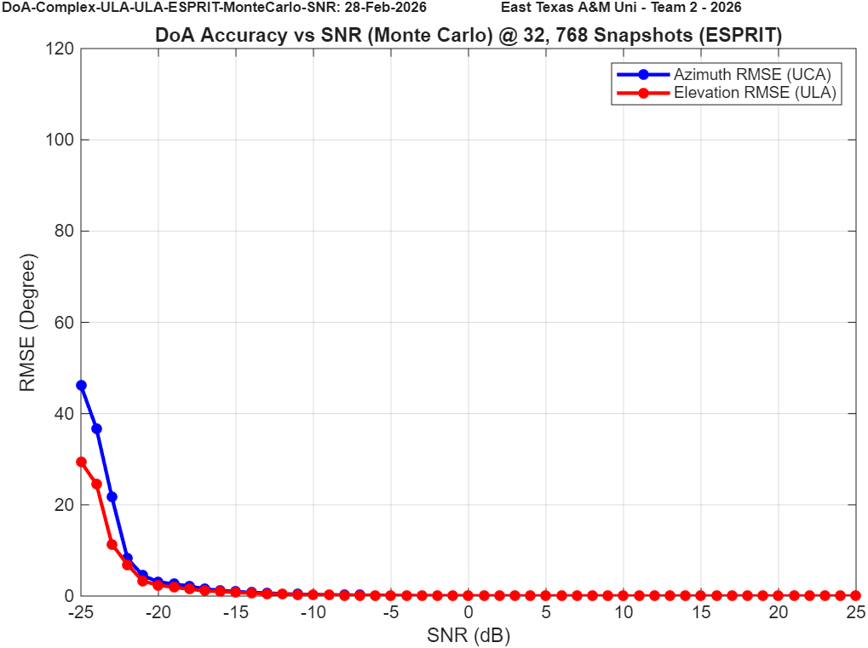
Fig 5. ESPRIT ULA/ULA DoA SNR vs. Accuracy Simulation

The final SNR vs. Accuracy simulation evaluates the MUSIC algorithm for the ULA/ULA configuration. Using the dual-linear array design provides improved SNR resilience, as the uniform linear geometry enhances the shift-invariant structure and stabilizes covariance estimation. As SNR increases, a clear separation between the signal and noise subspaces is observed, resulting in rapid convergence of the DoA estimates and reduced RMSE in both azimuth and elevation. These results demonstrate the robustness of the MUSIC algorithm when both array dimensions satisfy uniform linear structure.

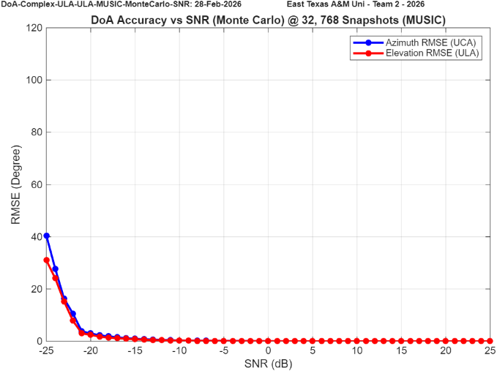
Fig 6. MUSIC ULA/ULA DoA SNR vs. Accuracy Simulation

Number of Snapshots vs. Accuracy

Paragraph 1 blah blah. Hello this is paragraph 1 and im triyn to extend it os that you can see how far the indentation goes. Thanks.

Paragraph 2 blah blah. Hello this is paragraph 2 and I’m trying to extend it so that you can see how far the indentation goes. Thanks.

ANTENNA RADIATION PATTERN
This section will discuss the bell pepper pattern of our UCA and the better pattern of the ULA. Also maybe the 2d plots for each.

UCA Pattern

Paragraph 1 blah blah. Hello this is paragraph 1 and im triyn to extend it os that you can see how far the indentation goes. Thanks.

Paragraph 2 blah blah. Hello this is paragraph 2 and I’m trying to extend it so that you can see how far the indentation goes. Thanks.

ULA Pattern

Paragraph 1 blah blah. Hello this is paragraph 1 and im triyn to extend it os that you can see how far the indentation goes. Thanks.

Paragraph 2 blah blah. Hello this is paragraph 2 and I’m trying to extend it so that you can see how far the indentation goes. Thanks.

LIVE DEMO TESTING SET-UP
This section will discuss how we test the apparatus, how far, important angles to test at, how we collect the data, and why to all of that.

Holy Apparatus Configuration

Paragraph 1 blah blah. Hello this is paragraph 1 and im triyn to extend it os that you can see how far the indentation goes. Thanks.

Paragraph 2 blah blah. Hello this is paragraph 2 and I’m trying to extend it so that you can see how far the indentation goes. Thanks.

Azimuth ..
Paragraph 1 blah blah. Hello this is paragraph 1 and im triyn to extend

LIVE DEMO TESTING
This section will discuss how we test the apparatus, how far, important angles to test at, how we collect the data, and why to all of that.

Holy Apparatus Configuration

Paragraph 1 blah blah. Hello this is paragraph 1 and im triyn to extend it os that you can see how far the indentation goes. Thanks.

Paragraph 2 blah blah. Hello this is paragraph 2 and I’m trying to extend it so that you can see how far the indentation goes. Thanks.

Azimuth ..

Paragraph 1 blah blah. Hello this is paragraph 1 and im triyn to extend it os that you can see how far the indentation goes. Thanks.

Paragraph 2 blah blah. Hello this is paragraph 2 and I’m trying to extend it so that you can see how far the indentation goes. Thanks.

Elevation ..

Paragraph 1 blah blah. Hello this is paragraph 1 and im triyn to extend it os that you can see how far the indentation goes. Thanks.

Paragraph 2 blah blah. Hello this is paragraph 2 and I’m trying to extend it so that you can see how far the indentation goes. Thanks.

Range ..

Paragraph 1 blah blah. Hello this is paragraph 1 and im triyn to extend it os that you can see how far the indentation goes. Thanks.

Paragraph 2 blah blah. Hello this is paragraph 2 and I’m trying to extend it so that you can see how far the indentation goes. Thanks.

Data Collection

Paragraph 1 blah blah. Hello this is paragraph 1 and im triyn to extend it os that you can see how far the indentation goes. Thanks.

Paragraph 2 blah blah. Hello this is paragraph 2 and I’m trying to extend it so that you can see how far the indentation goes. Thanks.

RESULTS AND OBSERVATIONS
This section we’ll talk about basically the entire project focus. Going to split up sections to static source and moving source, then talk about the performance from there. Remember to insert a text box to outline your figure and you need a specific figure caption by hitting numbered list and doing change list level to fig x.

Static Source

Paragraph 1 blah blah. Hello this is paragraph 1 and im triyn to extend it os that you can see how far the indentation goes. Thanks.

Paragraph 2 blah blah. Hello this is paragraph 2 and I’m trying to extend it so that you can see how far the indentation goes. Thanks.

Moving Source

Paragraph 1 blah blah. Hello this is paragraph 1 and im triyn to extend it os that you can see how far the indentation goes. Thanks.

Paragraph 2 blah blah. Hello this is paragraph 2 and I’m trying to extend it so that you can see how far the indentation goes. Thanks.

COMPARISON
This section will detail the comparison and maybe we can end it with a good message about our thoughts on our work.

Section A

Paragraph 1 blah blah. Hello this is paragraph 1 and im triyn to extend it os that you can see how far the indentation goes. Thanks.

Paragraph 2 blah blah. Hello this is paragraph 2 and I’m trying to extend it so that you can see how far the indentation goes. Thanks.

Section B

Paragraph 1 blah blah. Hello this is paragraph 1 and im triyn to extend it os that you can see how far the indentation goes. Thanks.

Paragraph 2 blah blah. Hello this is paragraph 2 and I’m trying to extend it so that you can see how far the indentation goes. Thanks.

Section C

Paragraph 1 blah blah. Hello this is paragraph 1 and im triyn to extend it os that you can see how far the indentation goes. Thanks.

Paragraph 2 blah blah. Hello this is paragraph 2 and I’m trying to extend it so that you can see how far the indentation goes. Thanks.

ACKNOWLEDGEMENTS
The authors would like to thank the Air Force Research Laboratory (AFRL) and the Wright Brothers Institute (WBI) for hosting and supporting the AFRL SDR University Challenge, and for providing the competition structure, technical feedback opportunities, and an evaluation venue for the project demonstration.
The authors also acknowledge East Texas A&M University (ETAMU) for institutional support and resources that enabled development and testing of the prototype system. Appreciation is extended to the project’s faculty advisor(s), technical mentors, and laboratory staff for guidance on RF hardware integration, calibration practices, and experimental methodology. Additional thanks are given to the challenge sponsors and tool providers who supported the program and student teams through hardware and software resources, including organizations such as MathWorks and National Instruments, as applicable to the competition year.

References
- Codău, C.; Buta, R.-C.; Păstrăv, A.; Dolea, P.; Palade, T.; Puschita, E. Experimental Evaluation of an SDR-Based UAV Localization System. Sensors 2024, 24, 2789. https://doi.org/10.3390/s24092789
- H. -C. Chen, T. -H. Lin, H. T. Kung, C. -K. Lin and Y. Gwon, "Determining RF angle of arrival using COTS antenna arrays: A field evaluation," MILCOM 2012 - 2012 IEEE Military Communications Conference, Orlando, FL, USA, 2012, pp. 1-6,
doi: 10.1109/MILCOM.2012.6415851
- O. A. Oumar, M. F. Siyau and T. P. Sattar, "Comparison between MUSIC and ESPRIT direction of arrival estimation algorithms for wireless communication systems," The First International Conference on Future Generation Communication Technologies, London, UK, 2012, pp. 99-103, doi: 10.1109/FGCT.2012.64765631
- https://wiki.analog.com/_media/resources/tools-software/linux-software/doa_whitepaper.pdf
- M. A. ihedrane, A. E. FAdl, and S. Bri, “Direction of Arrival Using 2-D Matrix Pencil Method,” Advances in Science, Technology and Engineering Systems Journal, vol. 4, no. 5, pp. 341–342, 2019, doi: https://doi.org/10.25046/aj040544.
- ‌Cristian Codău, R.-C. Buta, A. Păstrăv, P. Dolea, Tudor Palade, and E. Puschita, “Experimental Evaluation of an SDR-Based UAV Localization System,” Sensors, vol. 24, no. 9, pp. 2789–2789, Apr. 2024, doi: https://doi.org/10.3390/s24092789.
- ‌

Make sure to remove all placeholder and explanatory text from the template when you add your own text. This text should not be here in the final version!

